Answer 1

Click on Edit Virtual Machine Settings

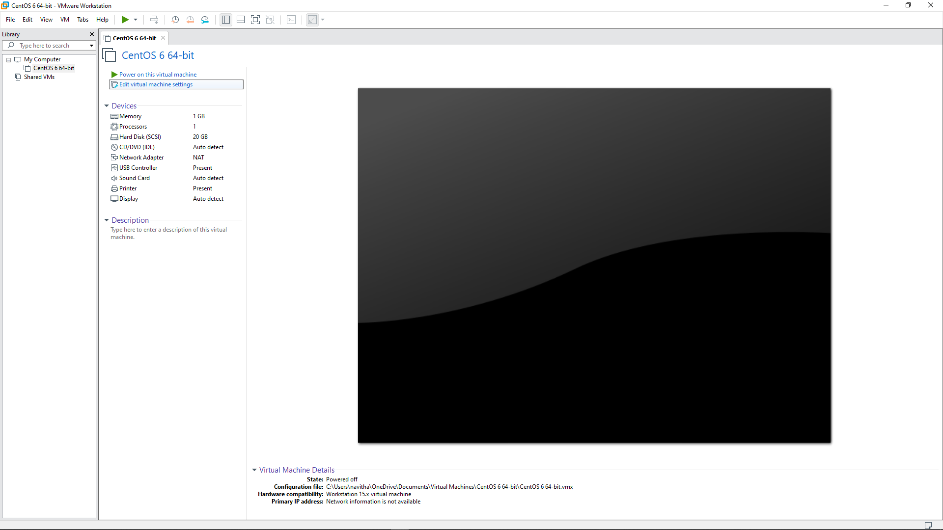

Click on Add button

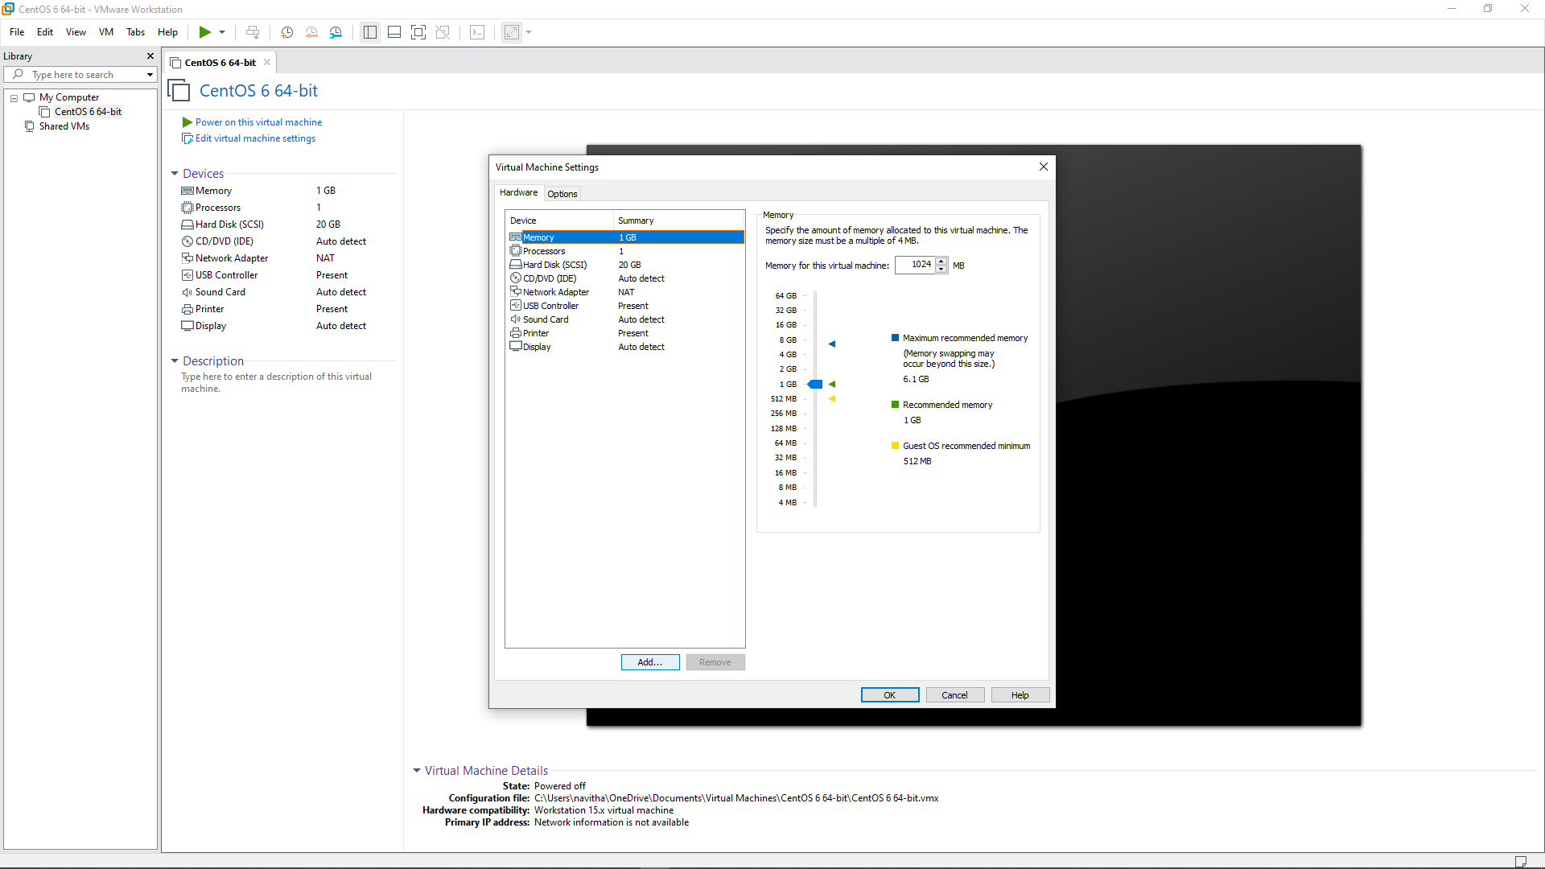

Select Hard Disk and Click on next

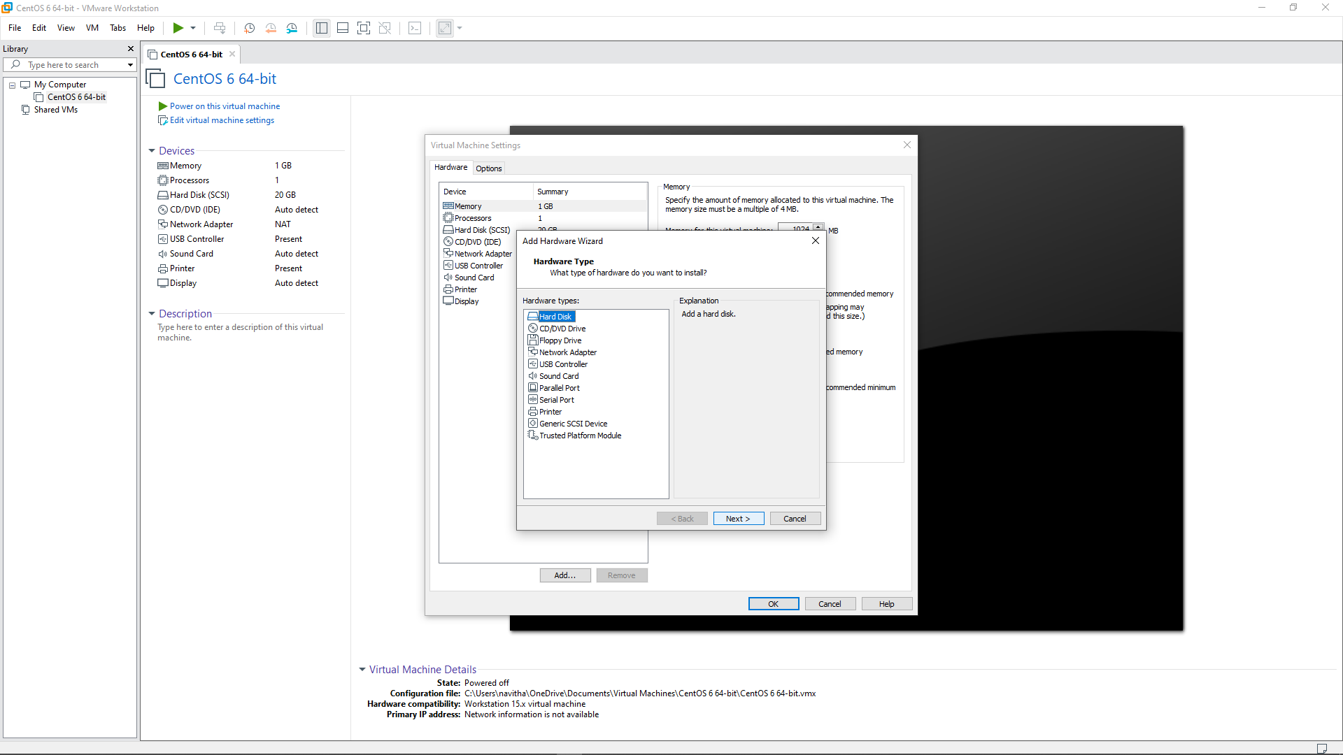

Select SCSI and Click on next

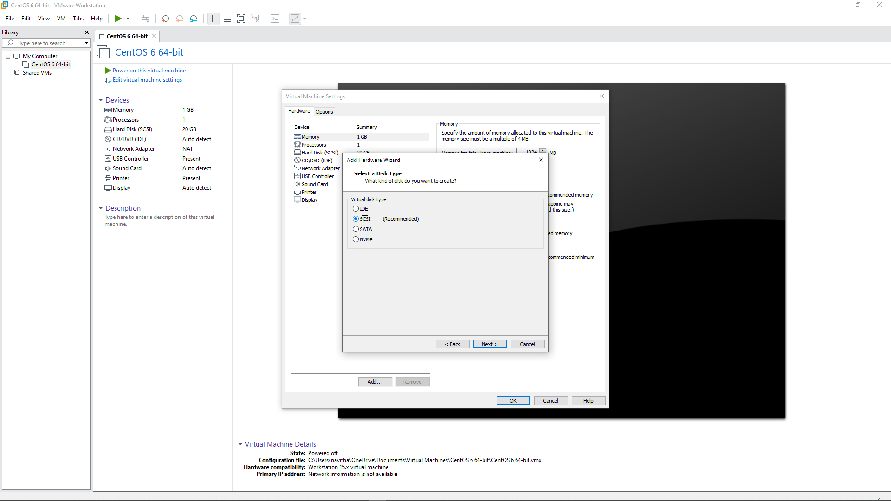

Select the first option and Click on next

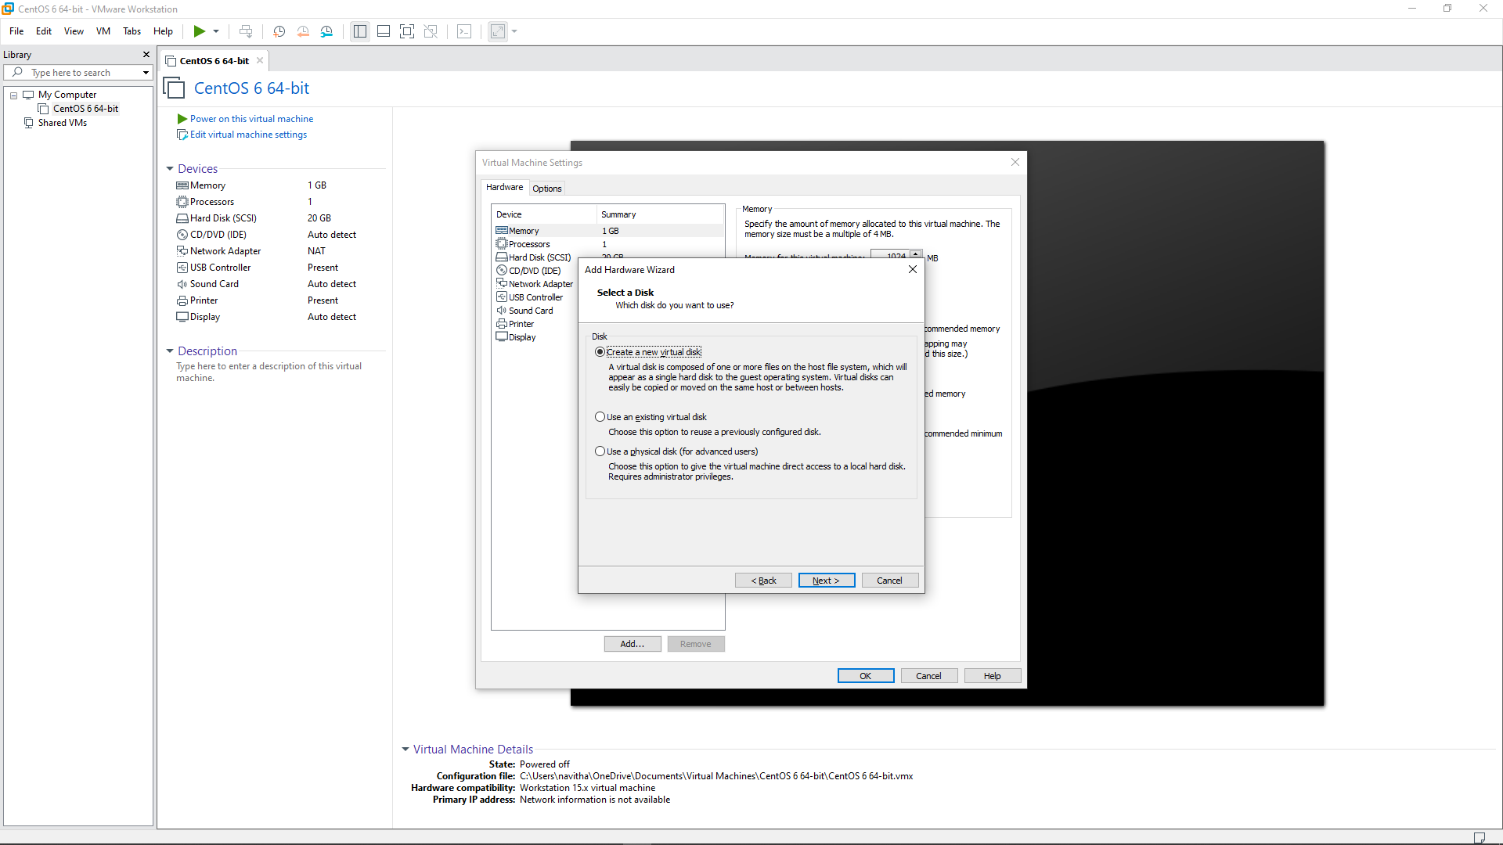

Change the Size of Disk as per requirement, select second Option and Click on next

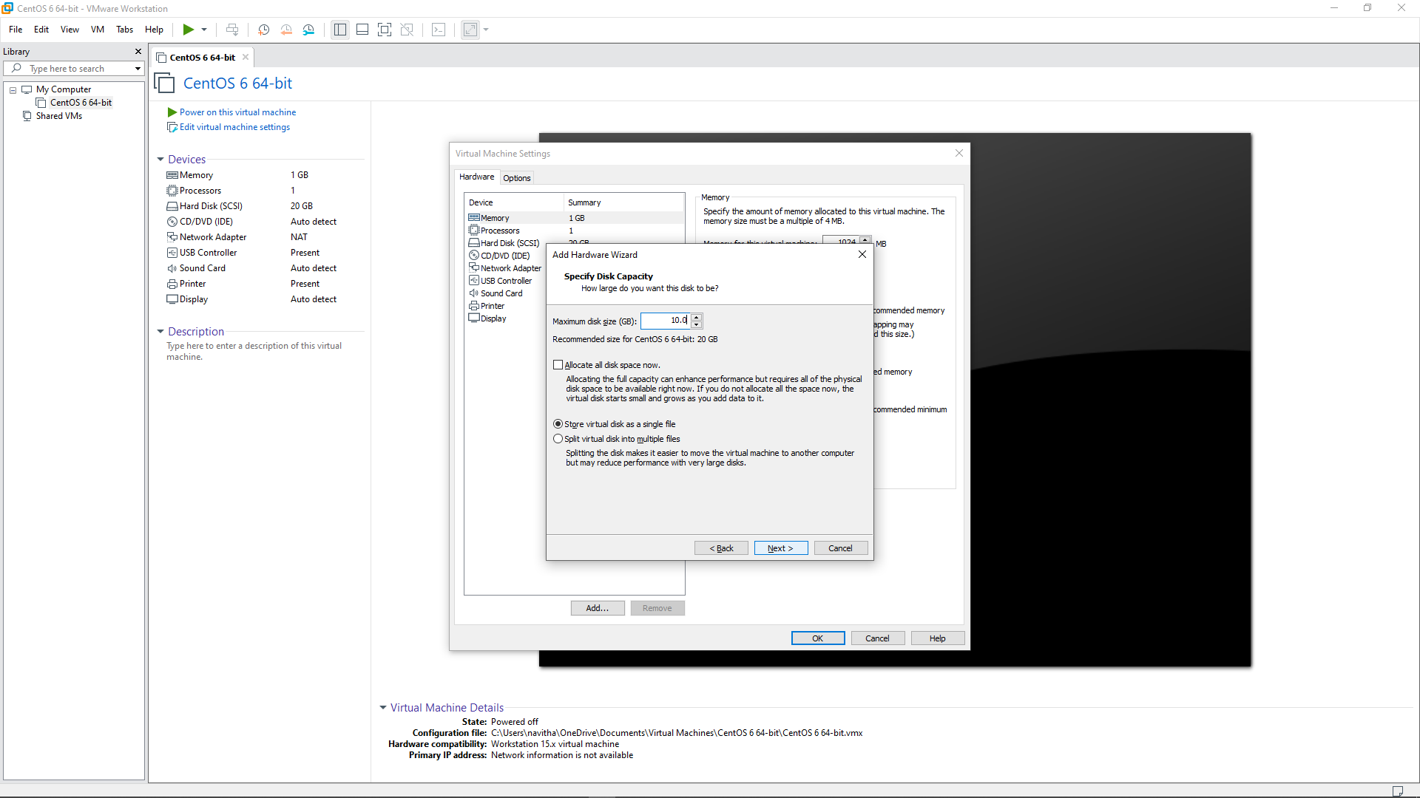

Click on OK button

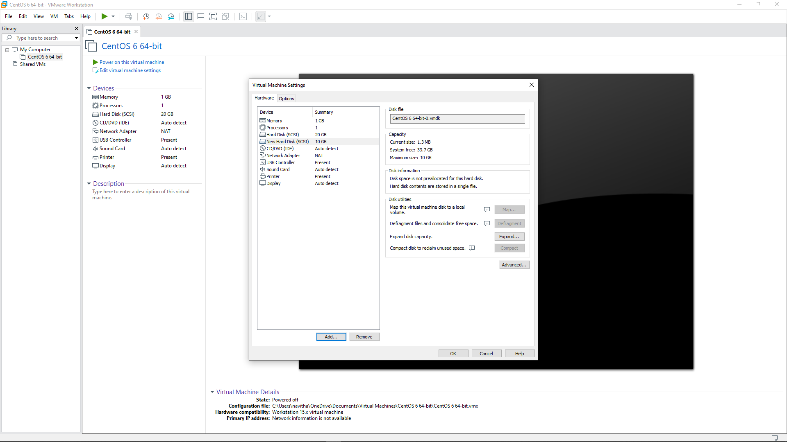

Using LSBLK command to see the new mounted disk

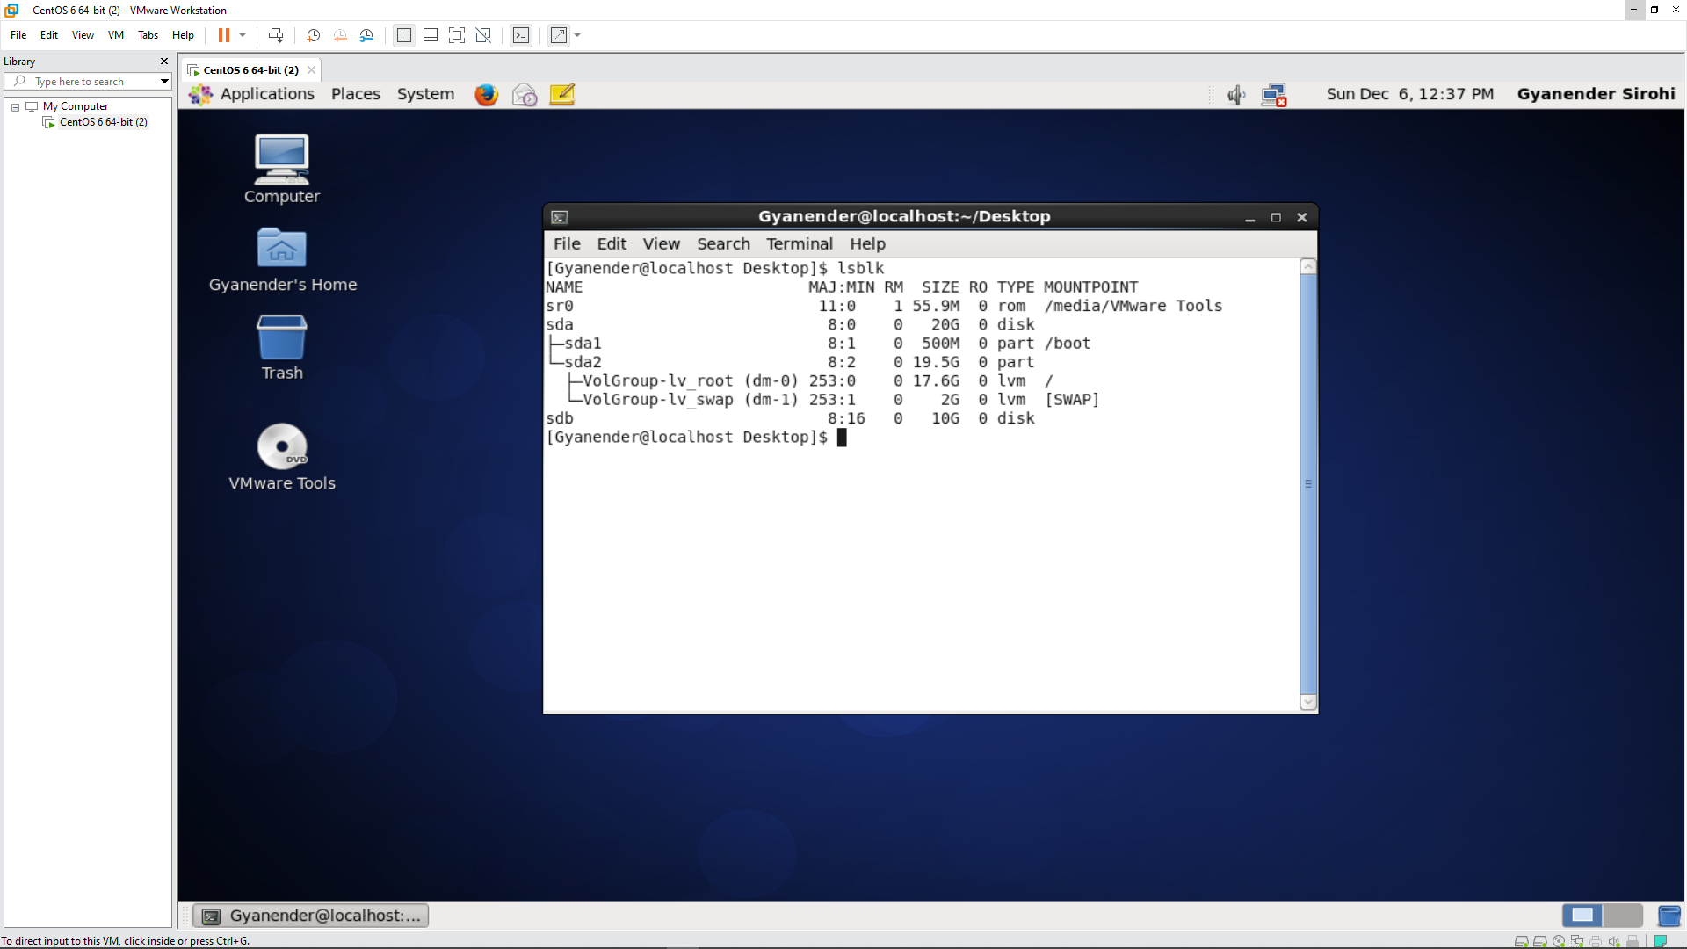

Answer 2

Using fdisk command to create partitions

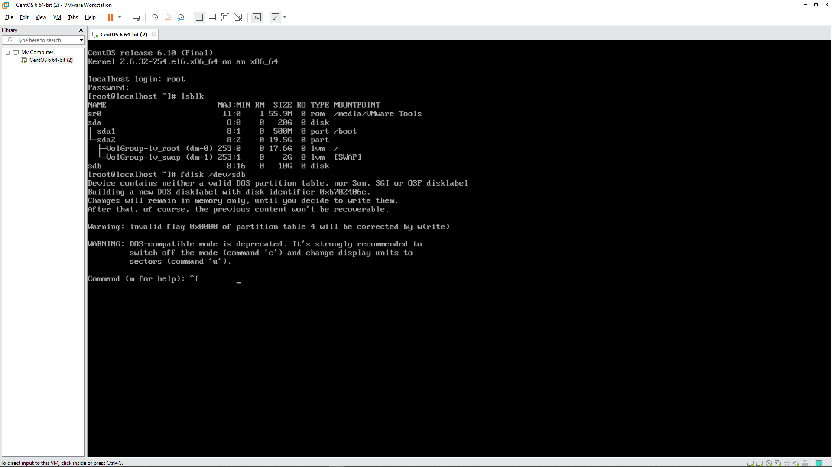

Using command p to print the partitions

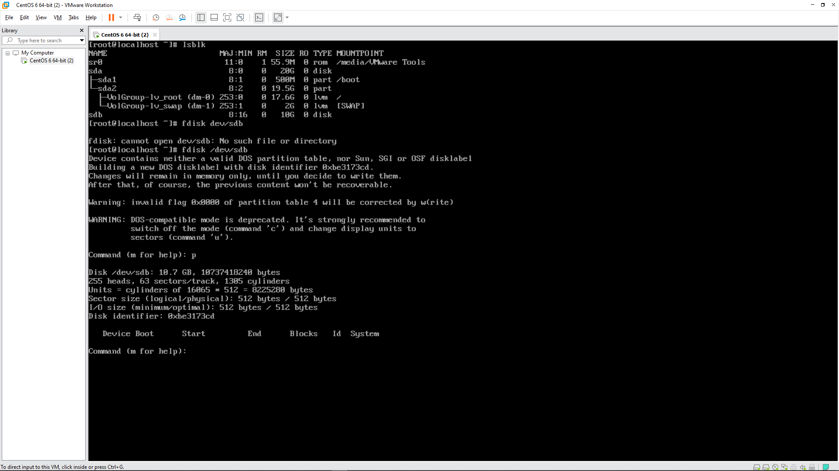

Using n command to create a new partition and p command for creating a primary partition

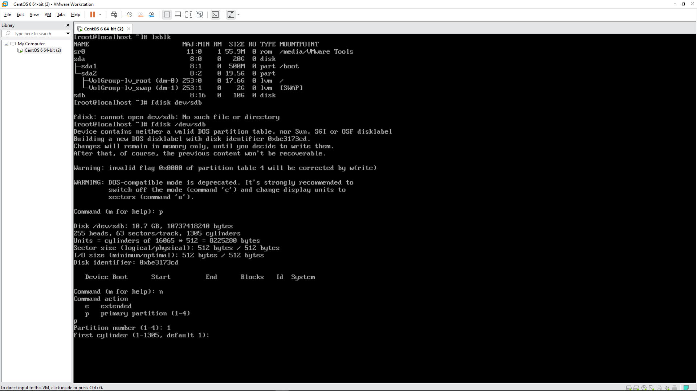

Specifying the size of the first partition

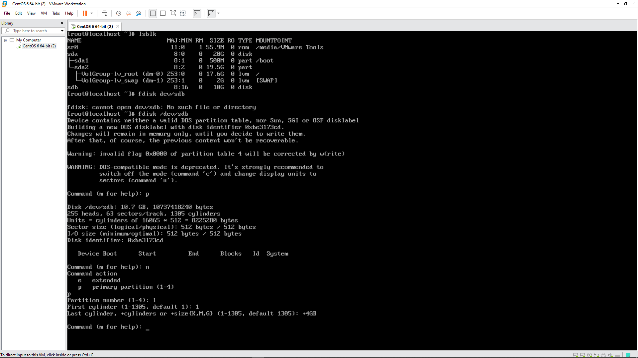

Printing the partitions created

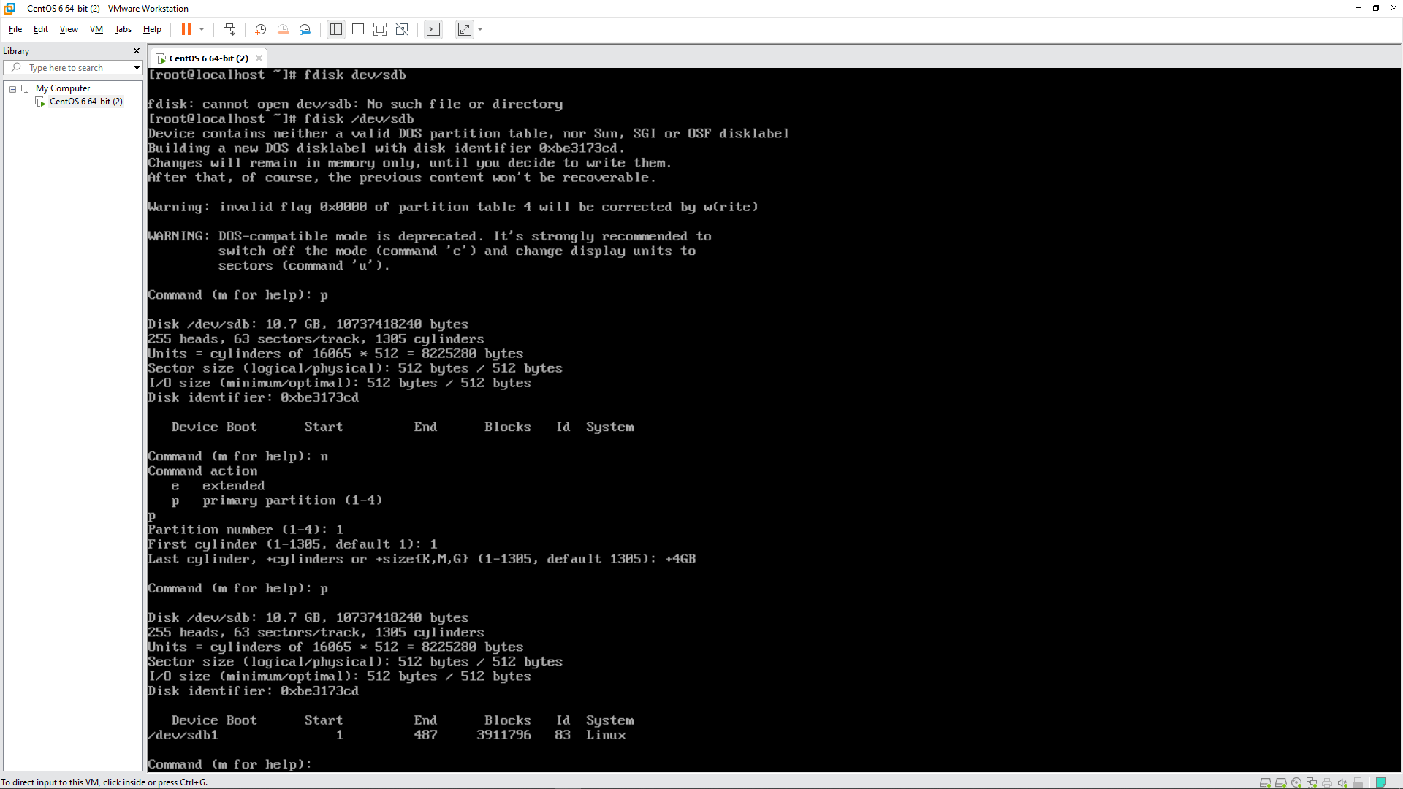

Creating the second partition with n and p command. Specifying the size of the partition

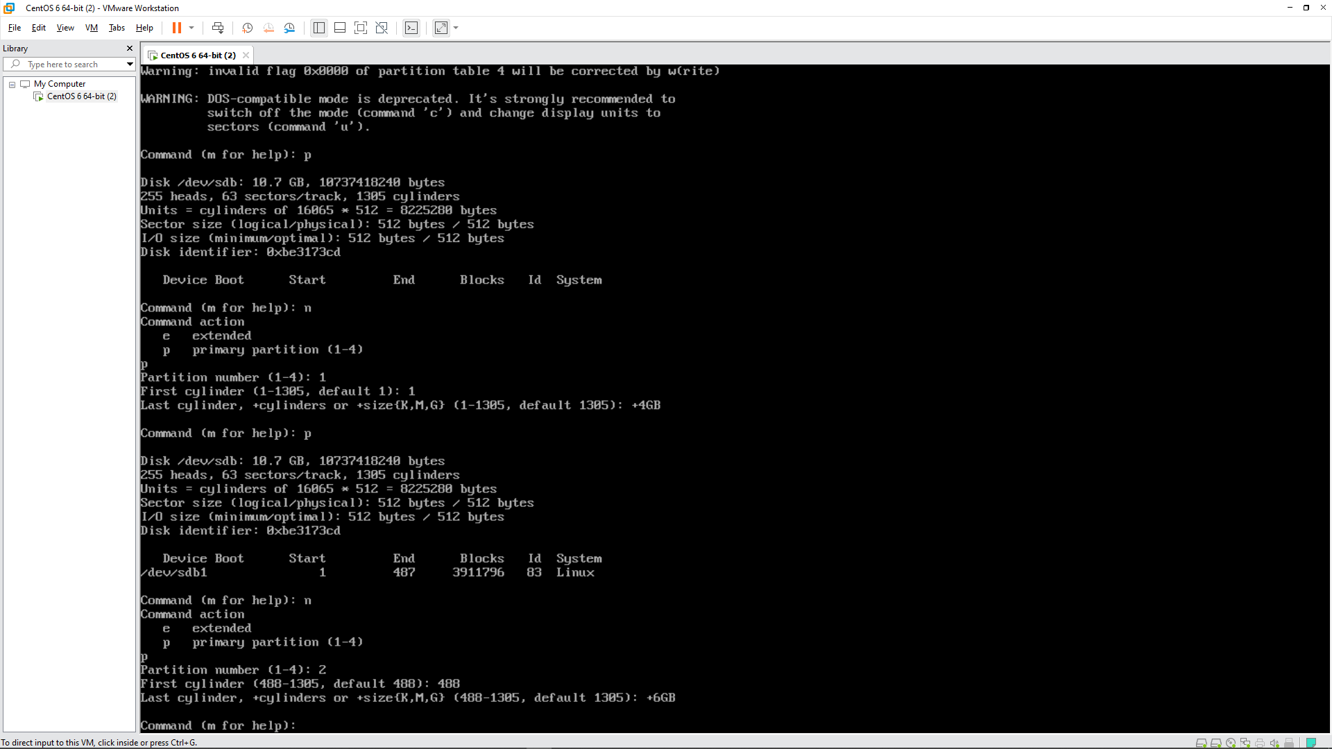

Printing the partitions created

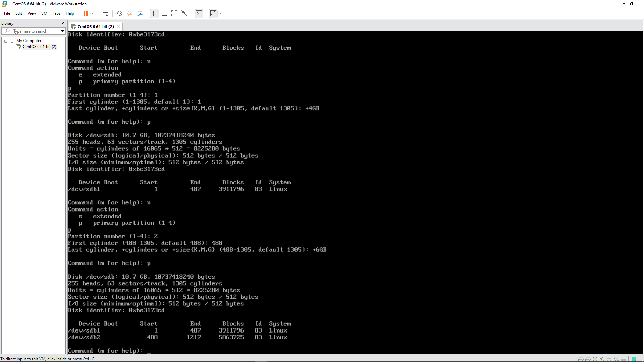

Writing the changes to the disk using w command

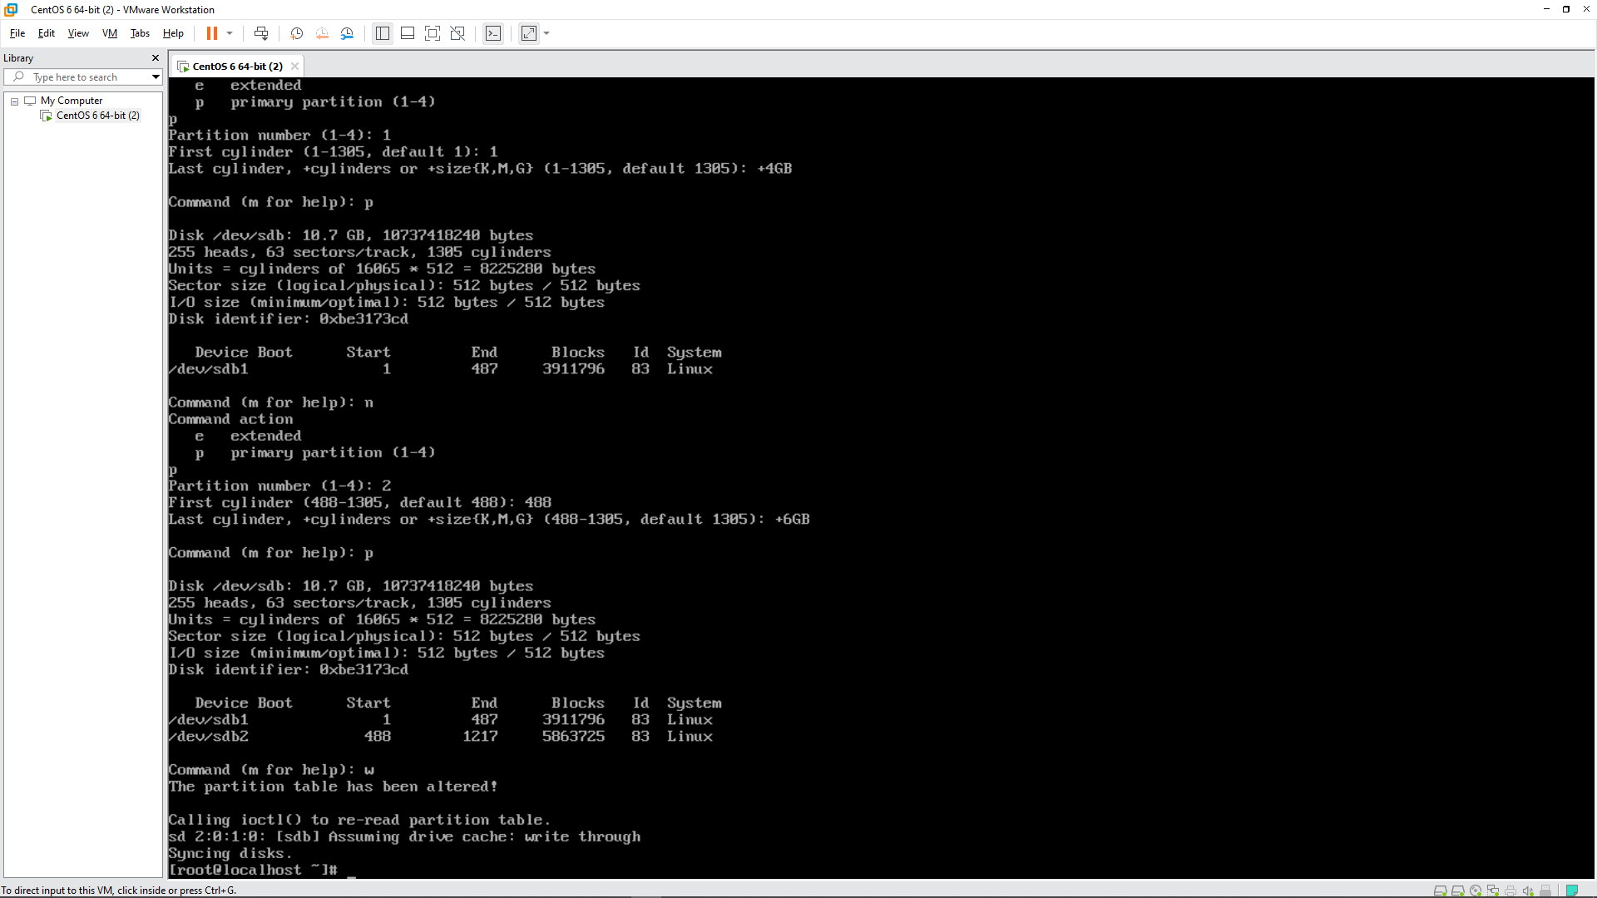

Answer 3

Formatting the first partition in XFS Format using mkfs.xfs command

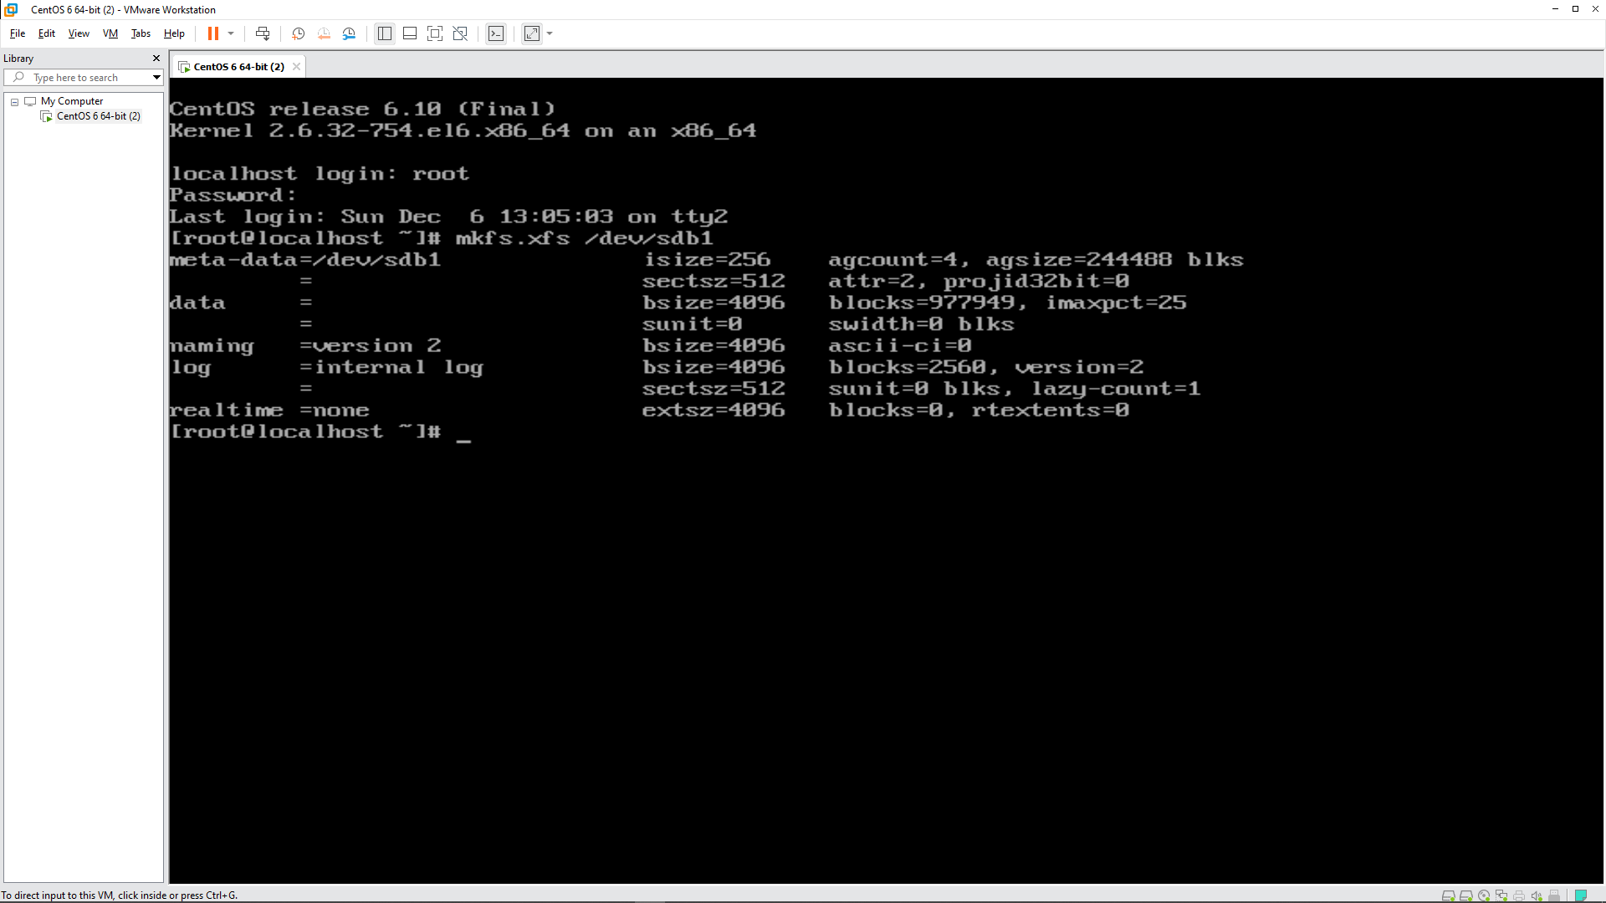

Formatting the second partition in EXT4 Format using mkfs.ext4 command

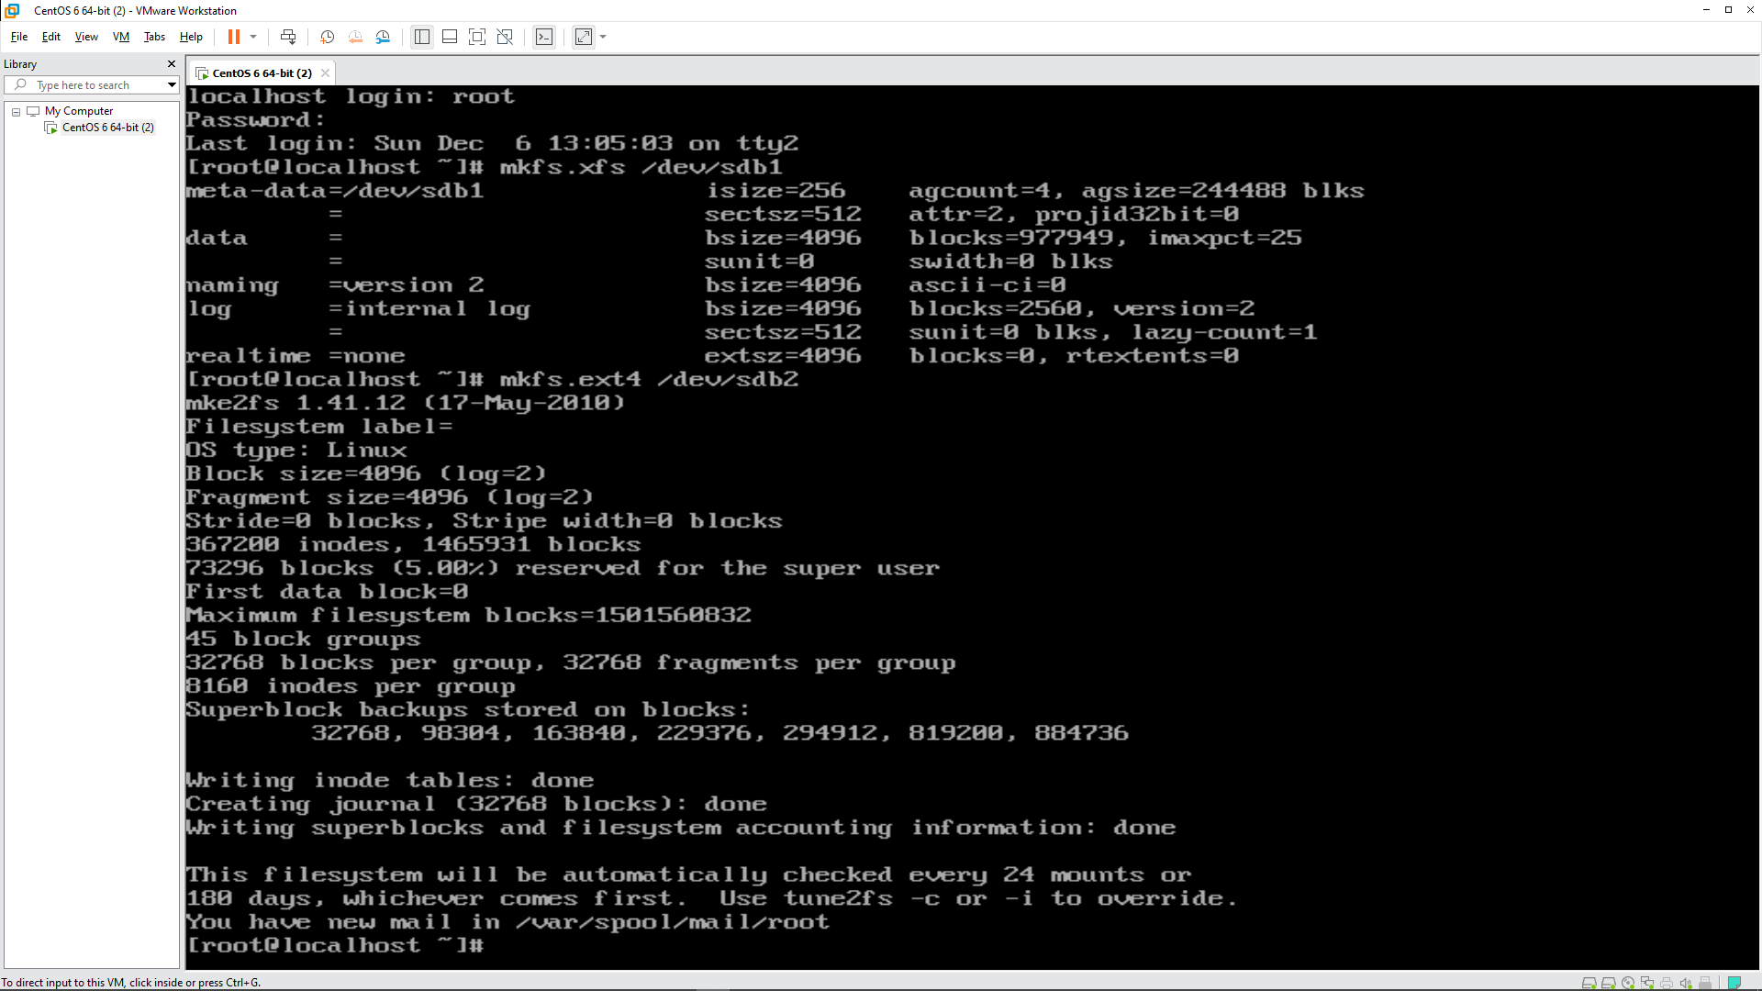

Answer 4

Making the Data and Music directories

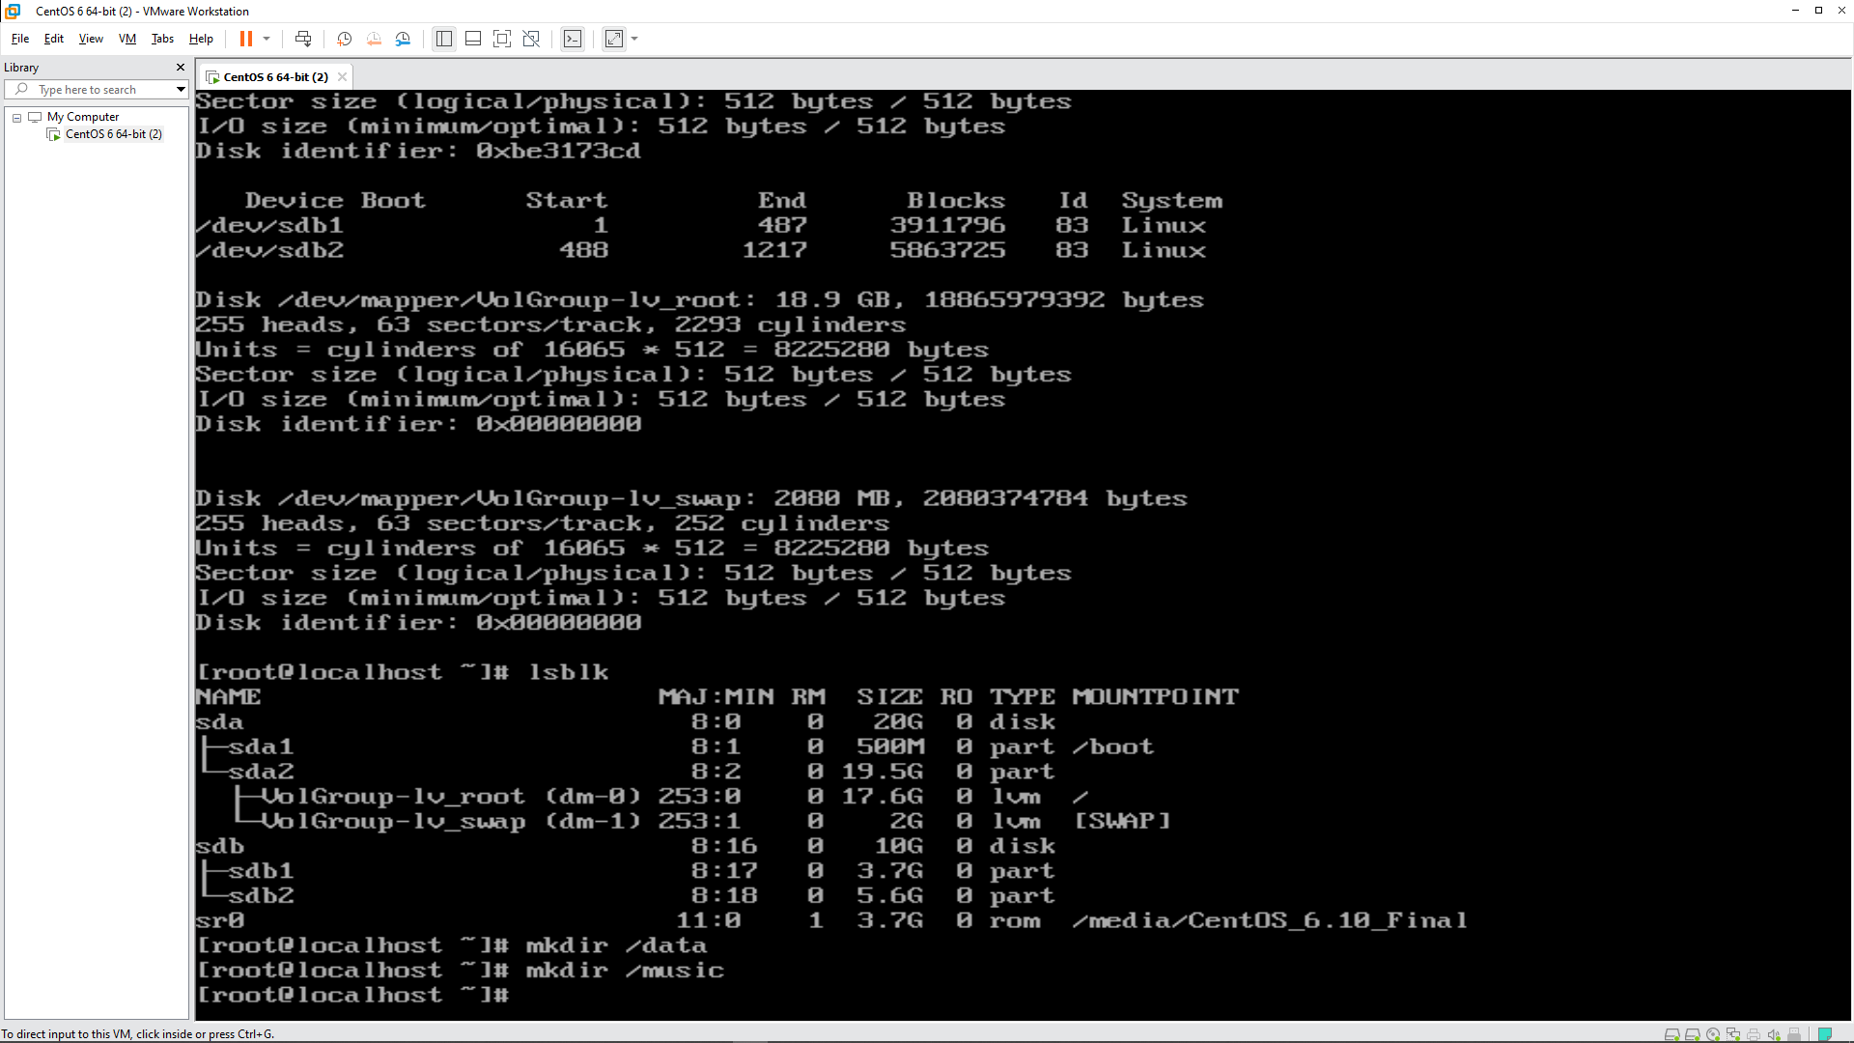

Mounting the Partitions to the Directories respectively

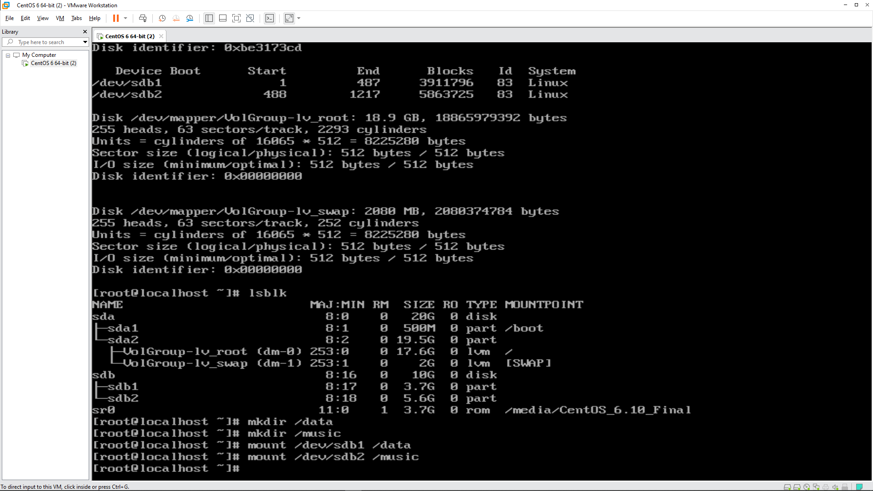

Using the df – h command to print the status of the partions

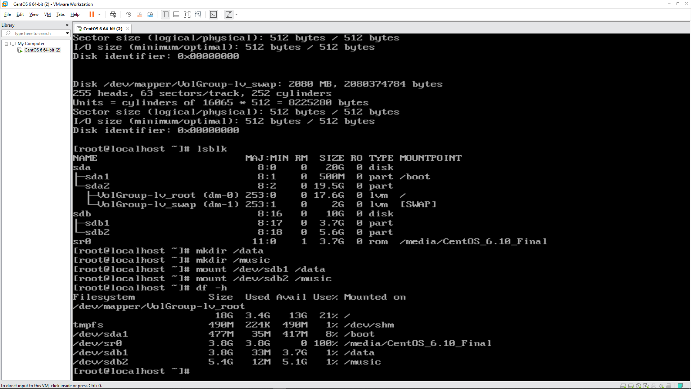

Answer 5

Using the seq command to create a text file of approx. 1GB inside the Data and Music directories

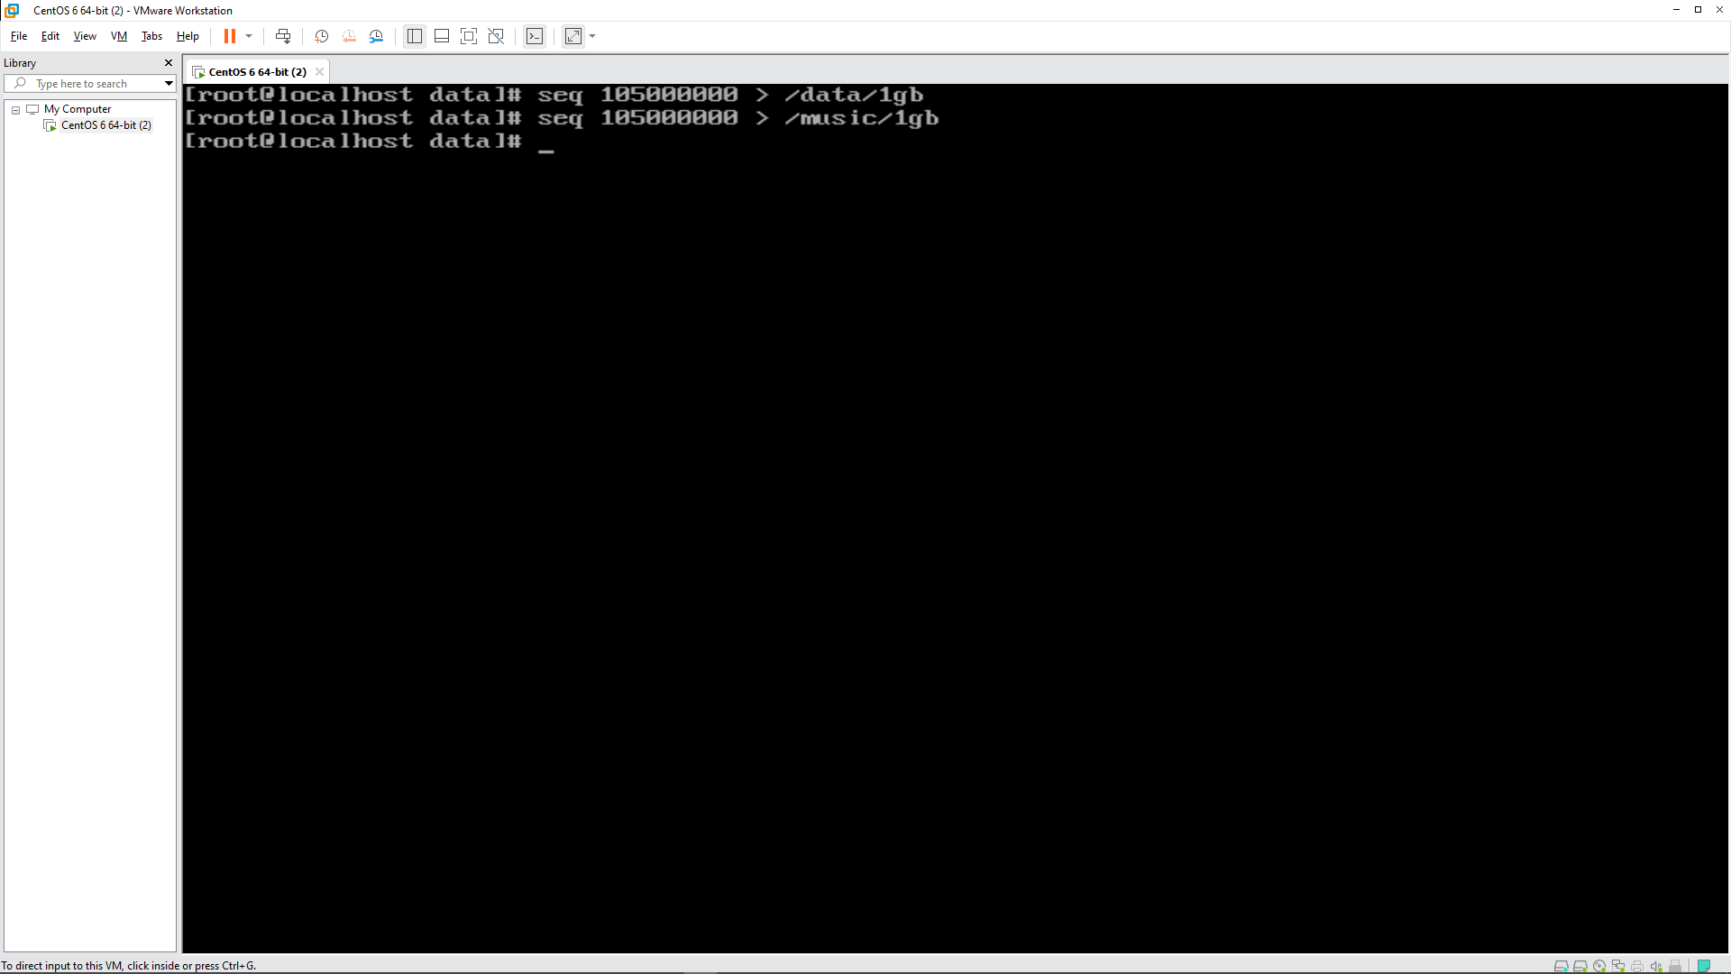

Answer 6

Using the df -ah command to print the status of the partitions to verify the consumption and free disk space

